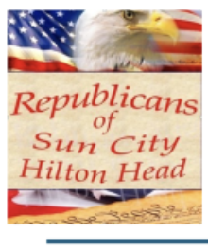
REPUBLICANS OF SUN CITY HILTON HEAD
SEPTEMBERFEST!!
Membership Registration Form
DATE & TIME  September 18, Noon | COST  $25 Members / $30 Non-Members | LOCATION  Town Square Pavillion | DEADLINE  Register by 9/11/2026
Catered by the Lunch Ladies, with music by the Sun City Harmonizers and Mike Morris the Piano Man. BYOB welcome if desired. Please print clearly and submit this completed form to register.
Drop off form in the lower mailbox of Gary Noakes, 46 Raven Glass Lane, Bluffton, SC 29909, or Tim Wyld's lower box at 214 Havenview Lane, Okatie, SC 29909.
Registrant Information
Full Name(s)
Email |  | Phone Number
Street Address
CAM # |  | Neighborhood
Check Number
Please attend and encourage your friends to join you! We need a large turnout in what is becoming the most important mid-term election in our lifetimes. Republic or Communism? Freedom or Forced Equality? Civility or Chaos? Strength or Appeasement? Private Ownership or Government Control? Secure Elections or No Representation? It's your choice.

